TPT - SOP

Nutanix – Reset the CVM Password

PREPARED BY

TABLE OF CONTENTS
Summary 3
Reset the password 4

Summary
The below links will help get you through the steps to reset the password for the CVMs if the Nutanix password gets locked out. The full links to performing the steps are below. These have been compiled and the extra garbage cut out in the steps right after this list.
Use this link to reset the password https://portal.nutanix.com/page/documents/kbs/details?targetId=kA060000000TSYoCAO and then Use this link to unlock the account https://portal.nutanix.com/page/documents/kbs/details?targetId=kA0VO0000006aX30AI

Reset the password
Steps:
- Log into RKE-DC03
- Change to the PuTTY directory (cd c:\Program Files\putty)
- Start Putty
- Select the appropriate Saved Session from the list for the Node that needs to be reset. Please note that using these outside of the password reset can have unintentional consequences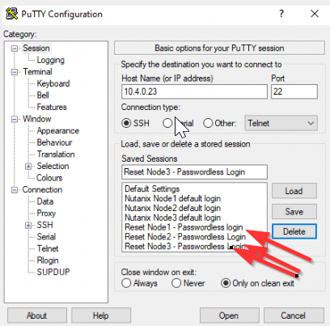
- Type “sudo password nutanix” and press enter
- Type in the password for the admin user
- Type in the new password for nutanix
- Retype the new password for nutanix
- The password is now reset. Lets make sure the account is not locked out
- Type “sudo su – nutanix”
- Type “allssh sudo faillock --user nutanix --reset”
- Connect from another PuTTY session to the host directly

